Birla Institute of Technology & Science, Pilani
Work Integrated Learning Programmes Division
First Semester 2025-2026
Assignment
(EC-1)

Course No. : SE*ZG504
Course Title : API-based Products
Weightage : 30%
No. of Pages = 12

No. of Questions = 6
Duration : 2 Weeks
Note to Students:
- Please ensure you capture the screenshots to demonstrate that you have performed the assignment.
- Each question carriers 10 marks. Total 30 Marks.
- Upload a single PDF file with all the necessary screenshots (question 1 and 2) and code snippets (for question 3).

✅ Question 1

Plagiarism Checker API using Cosine Similarity + ML
🎯 Goal: Classify whether a student’s submission is plagiarized using text similarity and ML classification.

🎯 Objective:
Build an app that:
- Takes two text documents as input
- Computes a plagiarism score using cosine similarity
- Uses an ML model to classify whether the second file is plagiarized based on similarity thresholds

🛠️ Tech Stack:
- Language: Python
- Libraries: scikit-learn, pandas, numpy
- Text Vectorization: TfidfVectorizer
- ML: Binary Classification (Logistic Regression/SVM)
- UI: Streamlit (simpler than Flask for rapid prototyping)

✅ Key Concepts:
- TF-IDF Vectorization
- Cosine Similarity
- Binary Classification using ML
- Streamlit for File Upload and Result Display

📁 Project Structure:
plagiarism_checker/
│
├── app.py # Streamlit web app
├── data_prep.py # data preparation script
├── model.py # ML model training script
├── utils.py # Helper functions (cosine similarity, preprocessing)
├── plagiarism_model.pkl # Trained ML model
├── sample_data/
│ ├── original.txt
│ └── submission.txt
└── requirements.txt

📦 Deliverables:
- Trained model: plagiarism_model.pkl
- Streamlit app: app.py
- Utilities: utils.py
- Training data: plagiarism_dataset.csv

🔢 Step-by-Step Guide

Step 0: Create your environment (optional but recommended)

a. Create a directory plagiarism_checker

b. Create a virtual environment (optional but recommended)
python -m venv venv
source venv/bin/activate
# On Windows: venv\Scripts\activate

Step 1: Install Required Packages
pip install numpy pandas scikit-learn streamlit
Optionally create a requirements.txt for easy installation:
numpy
pandas
scikit-learn
streamlit

Then run following pip command for the installations of the library
pip install -r requirements.txt

Step 2: Prepare utils.py (Helper Functions)
from sklearn.feature_extraction.text import TfidfVectorizer
from sklearn.metrics.pairwise import cosine_similarity
import numpy as np

def calculate_cosine_similarity(text1, text2):
vectorizer = TfidfVectorizer()
tfidf = vectorizer.fit_transform([text1, text2])
sim_matrix = cosine_similarity(tfidf[0:1], tfidf[1:2])
return sim_matrix[0][0]

def label_similarity(similarity_score, threshold=0.8):
return int(similarity_score >= threshold)

Step 3: Prepare Training Data - data_prep.py
Create a synthetic dataset (for demo) to train a binary classifier.
import pandas as pd
from utils import calculate_cosine_similarity

# Simulated training data
data = [
("This is the original sentence.", "This is the original sentence.", 1),
("The sky is blue and beautiful.", "The sky is blue.", 1),
("Machine learning is fun.", "I like pizza.", 0),
("Python is a great language.", "I use Java for backend.", 0),
]

# Compute similarity and label
rows = []
for original, submission, label in data:
sim = calculate_cosine_similarity(original, submission)
rows.append([original, submission, sim, label])

df = pd.DataFrame(rows, columns=["Original", "Submission", "Similarity", "Label"])
df.to_csv("plagiarism_dataset.csv", index=False)

Step 4: Train ML Model in model.py
import pandas as pd
from sklearn.linear_model import LogisticRegression
from sklearn.model_selection import train_test_split
import joblib

# Load data
df = pd.read_csv("plagiarism_dataset.csv")

X = df[['Similarity']]
y = df['Label']

# Split and train
X_train, X_test, y_train, y_test = train_test_split(X, y, random_state=42)
model = LogisticRegression()
model.fit(X_train, y_train)

# Save model
joblib.dump(model, 'plagiarism_model.pkl')

Step 5: Build the Web App in app.py
import streamlit as st
import joblib
from utils import calculate_cosine_similarity

# Load model
model = joblib.load("plagiarism_model.pkl")

st.title("📄 Plagiarism Checker")

# File upload
file1 = st.file_uploader("Upload Original File", type=["txt"])
file2 = st.file_uploader("Upload Submission File", type=["txt"])

if file1 and file2:
text1 = file1.read().decode("utf-8")
text2 = file2.read().decode("utf-8")

similarity = calculate_cosine_similarity(text1, text2)
prediction = model.predict([[similarity]])[0]
prob = model.predict_proba([[similarity]])[0][1]

st.markdown(f"**Cosine Similarity Score:** `{similarity:.2f}`")
st.markdown(f"**Plagiarism Probability:** `{prob:.2f}`")

if prediction == 1:
st.error("🔴 This submission is likely plagiarized.")
else:
st.success("🟢 This submission seems original.")

Step 6: Run the App
streamlit run app.py

💡 Output Example (Rendered in Streamlit):

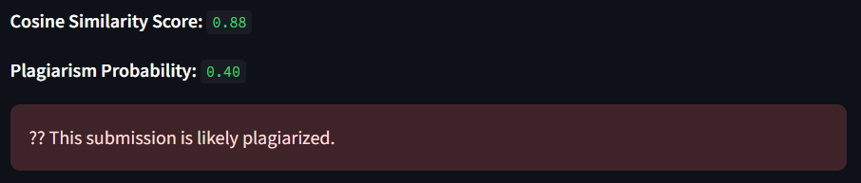

✅ Step-by-Step Update: Show highlighted matching segments using NLP techniques (e.g., difflib)
To highlight matching segments between two text files using NLP techniques, we can use Python’s built-in difflib module, particularly SequenceMatcher, to find and display the common parts between two documents.

✅ Objective:
Display the two documents with matching text segments highlighted to visualize the plagiarized portions.

🧠 Technique Used:
- difflib.SequenceMatcher compares two sequences and identifies matching blocks.
- We'll wrap the matching segments with <mark> tags (for highlighting in HTML).

🔧 Step-by-Step Implementation

Step 1: Add This Function to utils.py
import difflib

def highlight_matching_text(text1, text2):
"""
Returns HTML-highlighted versions of text1 and text2 where matching blocks are marked.
"""
matcher = difflib.SequenceMatcher(None, text1, text2)
blocks = matcher.get_matching_blocks()

def wrap_highlight(text, blocks, is_text1=True):
result = []
last_idx = 0
for block in blocks:
start = block.a if is_text1 else block.b
length = block.size
if length == 0:
continue
result.append(text[last_idx:start])
result.append(f"<mark>{text[start:start+length]}</mark>")
last_idx = start + length
result.append(text[last_idx:])
return ''.join(result)

return wrap_highlight(text1, blocks, True), wrap_highlight(text2, blocks, False)

Step 2: Update Your app.py to Display Highlighted Text
Add the following in the file after the similarity score section:
from utils import highlight_matching_text

...

if file1 and file2:
text1 = file1.read().decode("utf-8")
text2 = file2.read().decode("utf-8")

similarity = calculate_cosine_similarity(text1, text2)
prediction = model.predict([[similarity]])[0]
prob = model.predict_proba([[similarity]])[0][1]

st.markdown(f"**Cosine Similarity Score:** `{similarity:.2f}`")
st.markdown(f"**Plagiarism Probability:** `{prob:.2f}`")

if prediction == 1:
st.error("🔴 This submission is likely plagiarized.")
else:
st.success("🟢 This submission seems original.")

# Highlighted Text Display
st.subheader("📌 Highlighted Matching Text")
highlighted1, highlighted2 = highlight_matching_text(text1, text2)

st.markdown("**Original File (Highlighted):**", unsafe_allow_html=True)
st.markdown(f"<div style='background-color:#f9f9f9;padding:10px;border-radius:8px'>{highlighted1}</div>", unsafe_allow_html=True)

st.markdown("**Submission File (Highlighted):**", unsafe_allow_html=True)
st.markdown(f"<div style='background-color:#f0f0f0;padding:10px;border-radius:8px'>{highlighted2}</div>", unsafe_allow_html=True)

Step 3: Run the App
streamlit run app.py

💡 Output Example (Rendered in Streamlit):

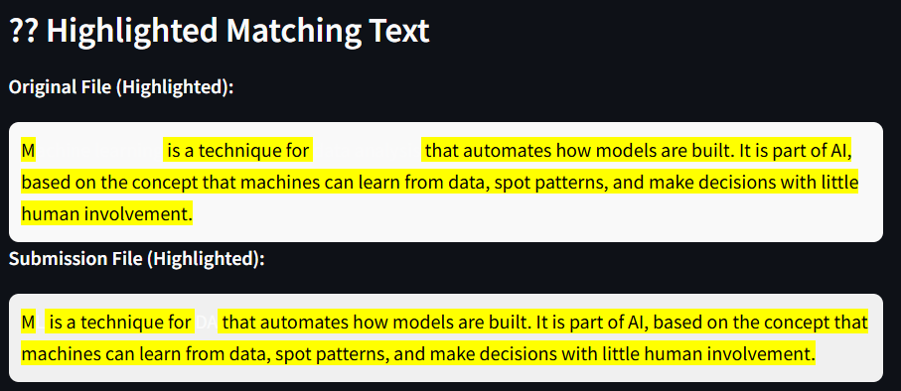

🧠 Plagiarism Checker using FastAPI + Cosine Similarity + ML

🎯 Objective
Classify whether a student’s submission is plagiarized using cosine similarity + ML, and highlight matching segments using NLP techniques.

🧰 Tech Stack
Component | Tool/Library
Language | Python
Vectorization | TfidfVectorizer
Similarity | cosine_similarity
ML Model | LogisticRegression
API Framework | Flask
Frontend | Streamlit
File Upload | Multipart handling

📁 Folder Structure
plagiarism_app/
│
├── flask_api/
│ ├── app.py # Flask API
│ ├── model.py # ML model training and saving
│ ├── utils.py # Helper functions
│ └── plagiarism_model.pkl # Saved ML model
│
├── streamlit_app/
│ └── app.py # Streamlit frontend
│
├── sample_data/
│ ├── original.txt
│ └── submission.txt
│
├── requirements.txt

🔧 Step 0: Create your enviornment

a. Create a directory plagiarism_app

b. Create a virtual environment (optional but recommended)
python -m venv venv
source venv/bin/activate
# On Windows: venv\Scripts\activate

🔧 Step 1: Install Required Libraries
pip install flask scikit-learn pandas joblib numpy streamlit requests
Alternatively add the modules to requirements.txt:
flask
scikit-learn
pandas
joblib
numpy
streamlit
requests

Then run the following command:
pip install -r requirements.txt

🧠 Step 2: utils.py (in flask_api/)
from sklearn.feature_extraction.text import TfidfVectorizer
from sklearn.metrics.pairwise import cosine_similarity
import difflib

def calculate_cosine_similarity(text1, text2):
vectorizer = TfidfVectorizer()
tfidf = vectorizer.fit_transform([text1, text2])
return cosine_similarity(tfidf[0:1], tfidf[1:2])[0][0]

def highlight_matching_text(text1, text2):
matcher = difflib.SequenceMatcher(None, text1, text2)
blocks = matcher.get_matching_blocks()

def highlight(text, blocks, is_text1=True):
result = []
last = 0
for block in blocks:
start = block.a if is_text1 else block.b
size = block.size
if size == 0:
continue
result.append(text[last:start])
result.append(f"<mark>{text[start:start+size]}</mark>")
last = start + size
result.append(text[last:])
return ''.join(result)

return highlight(text1, blocks, True), highlight(text2, blocks, False)

🏋️ Step 3: model.py (Train + Save)
import joblib
import pandas as pd
from sklearn.linear_model import LogisticRegression
from sklearn.model_selection import train_test_split
from utils import calculate_cosine_similarity

# Example dataset
data = [
("The quick brown fox jumps over the lazy dog.", "The quick brown fox jumps over the lazy dog.", 1),
("Data science is interesting.", "I love studying data science.", 1),
("Python is cool.", "Java is another language.", 0),
("Weather is nice today.", "Apples are tasty.", 0)
]

rows = []
for original, submission, label in data:
sim = calculate_cosine_similarity(original, submission)
rows.append([sim, label])

df = pd.DataFrame(rows, columns=["similarity", "label"])
X = df[["similarity"]]
y = df["label"]

model = LogisticRegression()
model.fit(X, y)
joblib.dump(model, "plagiarism_model.pkl")
print("Model trained and saved.")
Run this once to generate plagiarism_model.pkl.

🚀 Step 4: app.py (Flask API)
from flask import Flask, request, jsonify
from utils import calculate_cosine_similarity, highlight_matching_text
import joblib

app = Flask(__name__)
model = joblib.load("plagiarism_model.pkl")

@app.route("/check", methods=["POST"])
def check():
file1 = request.files['original']
file2 = request.files['submission']
text1 = file1.read().decode("utf-8")
text2 = file2.read().decode("utf-8")

similarity = calculate_cosine_similarity(text1, text2)
prediction = model.predict([[similarity]])[0]
probability = model.predict_proba([[similarity]])[0][1]
highlight1, highlight2 = highlight_matching_text(text1, text2)

return jsonify({
"similarity_score": round(similarity, 4),
"plagiarized": bool(prediction),
"probability": round(probability, 4),
"highlighted_original": highlight1,
"highlighted_submission": highlight2
})

if __name__ == "__main__":
app.run(debug=True, port=5000)
Run the API with:
python flask_api/app.py
API endpoint: http://localhost:5000/check

🎨 Step 5: Streamlit App (streamlit_app/app.py)
import streamlit as st
import requests

st.title("📄 Plagiarism Checker")

st.markdown("Upload original and submitted text files to check for plagiarism.")

original_file = st.file_uploader("Upload Original File", type=["txt"])
submission_file = st.file_uploader("Upload Submission File", type=["txt"])

if st.button("Check Plagiarism") and original_file and submission_file:
with st.spinner("Checking..."):
files = {
"original": original_file,
"submission": submission_file
}
try:
response = requests.post("http://localhost:5000/check", files=files)
if response.status_code == 200:
data = response.json()
st.metric("Similarity Score", f"{data['similarity_score'] * 100:.2f}%")
st.metric("Plagiarism Probability", f"{data['probability'] * 100:.2f}%")
st.success("Plagiarism Detected" if data["plagiarized"] else "No Plagiarism Detected")

st.markdown("### 🔍 Highlighted Matches in Original")
st.markdown(data["highlighted_original"], unsafe_allow_html=True)

st.markdown("### 🔍 Highlighted Matches in Submission")
st.markdown(data["highlighted_submission"], unsafe_allow_html=True)
else:
st.error("Error from Flask API")
except Exception as e:
st.error(f"Connection failed: {e}")

🎨 Step 6: Run the frontend
streamlit run streamlit_app/app.py

✅ Question 2
Perform rate limiting and request size limiting with KONG API Gateway.

✅ Question 3
Implement TokenBucket and Leaky Bucket rate limiting algorithms in Java/Python/c#.

